**P8 – Routine Maintenance**

Computers require maintenance to continue to work at their full capacity, otherwise they slow down and become less reliable over time.

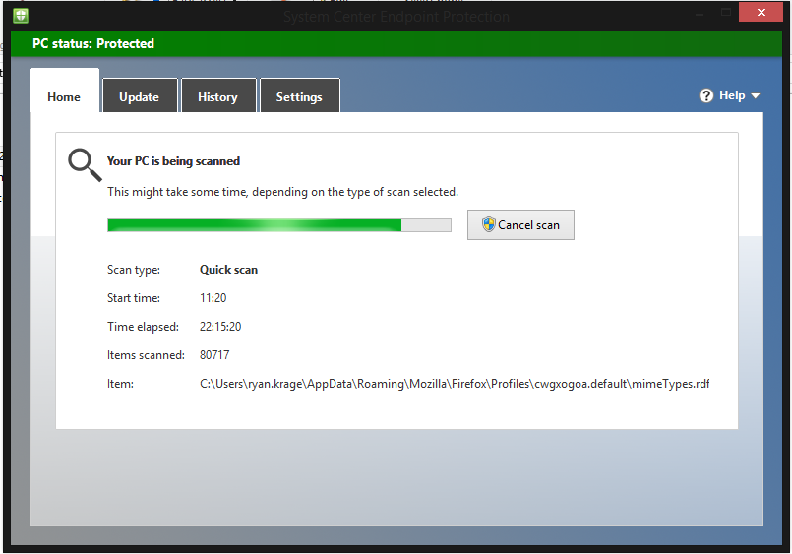

This is a routine anti-virus scan, which will detect and remove malicious software which could steal, corrupt or delete files and use up system resources. Regular scanning will prevent the computer from becoming infected.

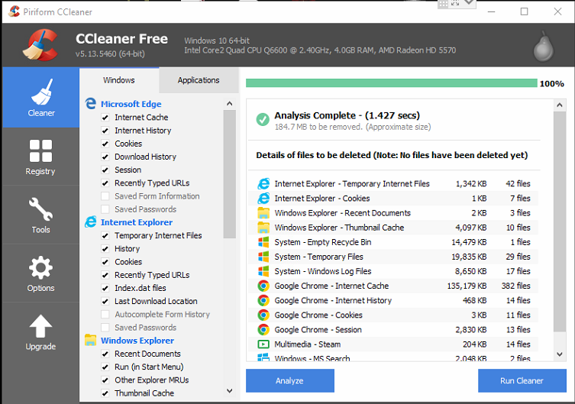

This is Ccleaner, a utility program that finds unwanted files, such as temp and cache files, or duplicates, and deletes them. It can also fix registry and disk errors.

This will free up storage space, and keep the disk defragmented, reducing access times which will improve the performance of the computer.

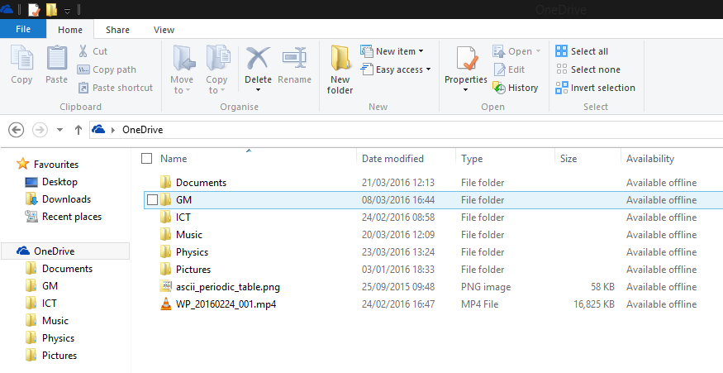

This is a OneDrive folder, which syncs all of the sub-folders and documents inside it across other devices signed into the same OneDrive account (including computers and phones/tablets) and backs up them up on Microsoft’s servers. This means the files can be accessed anywhere with an internet connection, and if they are lost on one or all devices, they can be recovered from the cloud.